KINGDOM OF SAUDI ARABIA
Ministry of Environment, Water & Agriculture

Industrial Waste-to-Water
Intelligence System

A Proposal for Pilot Implementation at Jubail Industrial City

Submitted to MEWA · March 2026 · Confidential

1. EXECUTIVE SUMMARY

Saudi Arabia faces an escalating structural water deficit. Total water demand currently exceeds 8 million cubic metres per day and is forecast to reach 12.3 million m³/day by 2040, yet the Kingdom's natural freshwater availability stands at only 2.4 billion m³ annually, well below 2% of total demand. The government's answer (massive desalination) is working, but comes at a significant cost: $5.90 per cubic metre in full lifecycle terms, heavy energy dependency, and a growing brine discharge problem estimated to reach 1.5 million m³/day.

This proposal presents a complementary, non-competing solution: an Industrial Waste-to-Water Intelligence System that converts already generated industrial waste streams, waste heat, flue gas moisture, desalination brine, produced water, and cooling losses, into recoverable, usable water. These streams currently represent untapped potential at low incremental energy cost, since the heat and moisture are by-products of operations that run regardless.

THE PROPOSAL
We request MEWA's approval and co-sponsorship for a Phase 1 Pilot Programme at Jubail Industrial City (the Kingdom's largest industrial zone) targeting 50,000 m³/day of additional water recovery from existing industrial waste streams. At an estimated recovery cost of $0.35–$0.45 per cubic metre (using pre-existing industrial heat), this represents a potential saving of $1.5–2.0 million per day against conventional desalination costs at full scale. The pilot is designed to be modular, replicable, and fully aligned with Vision 2030 and the National Water Strategy 2030.

12.3M m³  Daily Demand by 2040  vs. 8M m³ today | 1.5M m³/d  Projected Brine Discharge  currently wasted | $5.90/m³  Desalination Cost (full)  SWCC lifecycle basis | 50,000 m³/d  Proposed Pilot Recovery  Phase 1: Jubail

2. STRATEGIC CONTEXT & ALIGNMENT

Saudi Arabia is the world's largest producer of desalinated water, with 11.5 million m³/day of capacity in 2023 and an ambition to reach 13.3 million m³/day by end of 2024. Yet demand growth, driven by a population projected to reach 44.9 million by 2040, continues to outpace supply. MEWA's own projections show a structural gap of 4.5 million m³/day of urban demand that committed supply cannot meet without new solutions.

Alignment with National Water Strategy 2030 & Vision 2030
Strategic Objective | This Proposal's Contribution
Meet 90% of water demand through desalination by 2030 | Reduces pressure on primary desalination infrastructure by recovering supplementary water from brine and industrial heat
Reduce per capita consumption by 43% (263L → 150L/day) | Increases total water availability without behavioural demand, effectively same outcome
Cut water production costs by 50% by 2035 | Recovery cost of ~$0.40/m³ vs $5.90/m³ full lifecycle, directly contributes to cost reduction targets
Achieve 90% water reuse by 2040 | Industrial produced water and brine secondary recovery contribute directly to reuse metrics
Reduce non-renewable groundwater reliance by 90% by 2035 | Every additional m³ recovered from waste streams displaces groundwater extraction
Saudi Green Initiative: industrial decarbonisation | Using pre-existing waste heat eliminates new energy consumption; reduces CO₂ per m³ of water produced

Crown Prince Mohammed bin Salman established the Global Water Organization in Riyadh in September 2023, positioning the Kingdom as the global authority on water sustainability. A domestically implemented waste-to-water programme at industrial scale would serve as a flagship demonstration of Saudi technical leadership, directly supporting the Organization's mandate.

3. THE WATER GAP & THE WASTE OPPORTUNITY

The Demand-Supply Imbalance
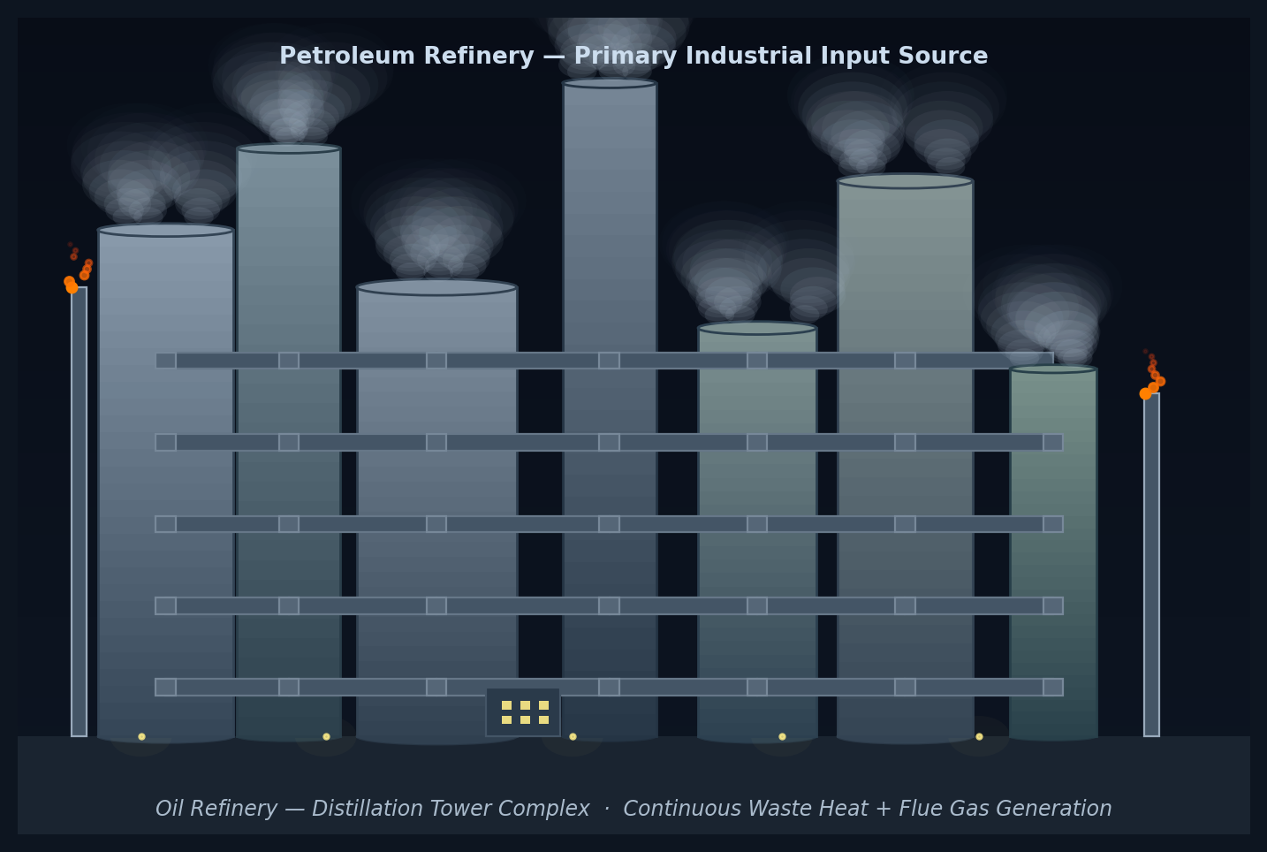
Fig. 1 Saudi Aramco refinery complex, Jubail Industrial City — primary source of high-grade waste heat, flue gas, cooling water losses, and produced water; combined throughput exceeds 500,000 bbl/day
Metric | Current (2023–24) | Projected (2040) | Gap / Change
Total water demand | 8.0 M m³/day | 12.3 M m³/day | +4.3 M m³/day (+54%)
Desalination capacity | 11.5 M m³/day | ~13.3 M m³/day (2024 target) | Capacity growth lagging demand
Non-renewable groundwater use | ~3.2 M m³/day | Target: 90% reduction by 2035 | Urgent phase-out required
Per capita daily consumption | 263 litres | Target: 150 litres by 2030 | 43% reduction needed
Water reuse rate | ~65% | Target: 90% by 2040 | 25 pp improvement needed
Brine discharge | ~1.0–1.5 M m³/day | 1.5 M m³/day+ (projected) | Environmental liability growing

The Untapped Industrial Waste Streams
Saudi Arabia's industrial complex (anchored at Jubail, Yanbu, Ras Al-Khair, and Dammam) generates continuous by-product streams that contain recoverable water potential. These are not hypothetical sources; they are active, daily outputs of operations that will continue to run regardless of whether a recovery system is present.

Waste Stream | Primary Source | Current Status | Recovery Mechanism | Estimated Potential
Waste Heat | Refineries, petrochemical plants, power generation | Largely vented or dissipated | Multi-Effect Distillation (MED) using residual heat | Significant, drives all thermal recovery
Desalination Brine | RO and MSF desalination plants | Discharged to Arabian Gulf (salinity +5–10 g/L above ambient) | Secondary thermal distillation | 20–30% additional water from brine stream
Flue Gas Moisture | Industrial exhaust stacks | Released to atmosphere | Cooling condensation recovery | Moderate; concentrated at point sources
Produced Water | Oil extraction operations | Re-injected or partially treated | Advanced filtration + thermal polishing | High volume; requires treatment investment
Cooling Tower Losses | All large industrial cooling systems | ~1–3% of circulated volume lost to evaporation | Drift eliminators + vapour condensation | Incremental but continuous

4. SYSTEM DESIGN: CENTRALIZED THERMAL RECOVERY HUB

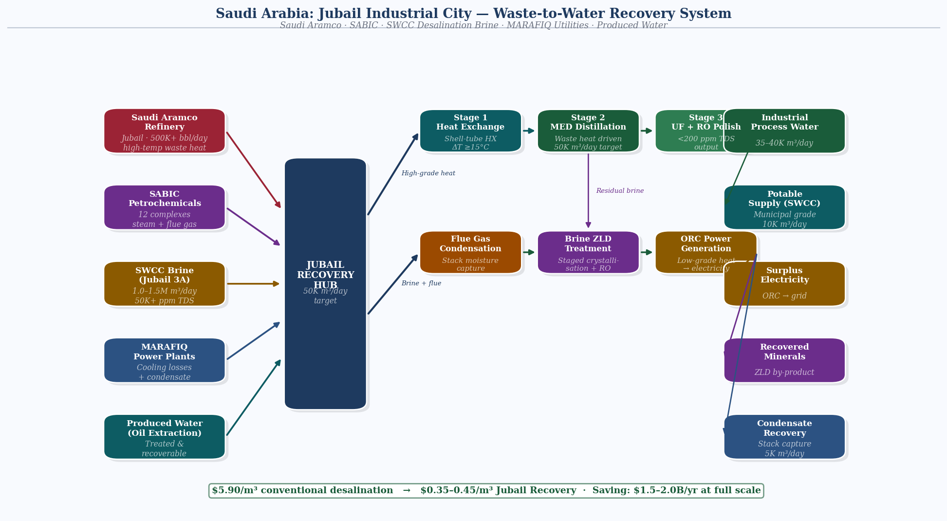
Fig. 2 Process architecture — Jubail Industrial City Recovery System: five source streams aggregated through recovery hub, processed across six stages, dispatched to five output streams at Phase 1 target of 50,000 m³/day
The proposed system architecture is a Centralized Industrial Thermal Hub, aggregating waste heat and moisture from multiple co-located industrial sources and routing them to a shared processing facility. This model is preferred over distributed nodes for the Jubail pilot due to the density of co-located heavy industry, the efficiency gains from centralized heat aggregation, and the availability of shared utility infrastructure.

Processing Flow
Waste Heat  Collection | → | Thermal  Exchangers | → | Multi-Effect  Distillation | → | Condensation  & Polish | → | Quality  Assurance | → Storage  & Distribution

Technical Module Specification
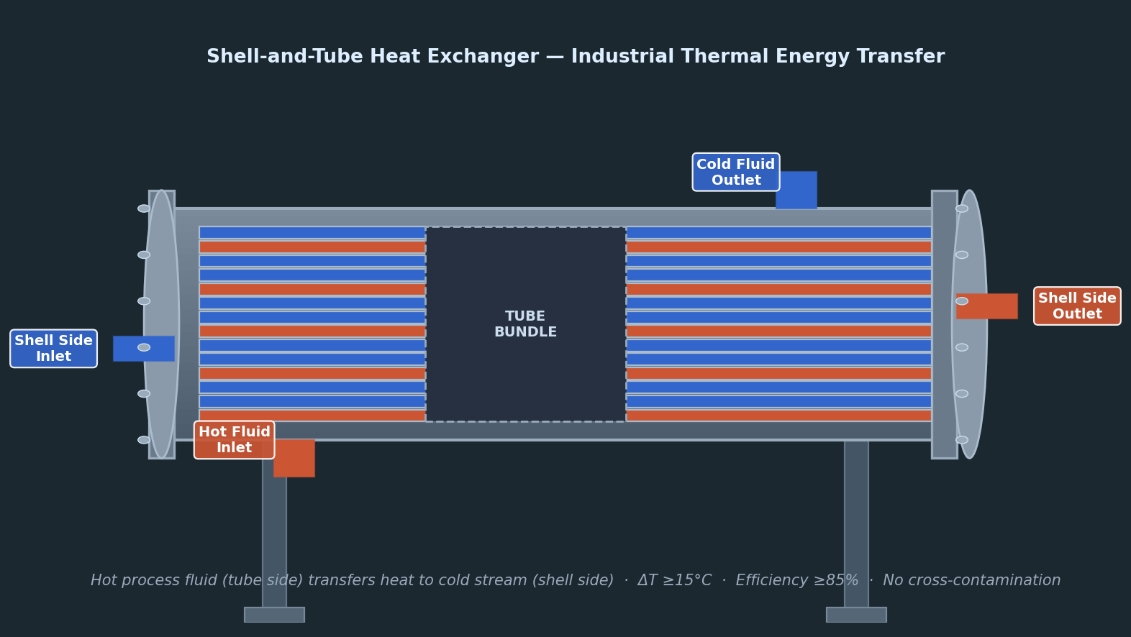
Fig. 3 Shell-and-tube heat exchanger — routes Saudi Aramco and SABIC process heat to brine secondary recovery; minimum delta-T 15°C; efficiency >= 85%
Module | Technology | Input | Output Quality | Key Specification
Heat Exchange Network | Shell-and-tube + plate heat exchangers | Industrial process heat (80°C–300°C) | Thermal energy at usable range | Minimum ΔT 15°C; efficiency ≥85%
Brine Secondary Recovery | Multi-Effect Distillation (MED) | Desalination brine (55,000–70,000 ppm TDS) | Permeate: <500 ppm TDS | Target: 25% additional recovery from brine
Flue Gas Condensation | Direct contact condensers + cooling coils | Exhaust gas at 120°C–200°C | Condensate (requires treatment) | Recovery efficiency 60–75% of moisture content
Produced Water Treatment | API separation + ultrafiltration + RO polishing | Produced water (variable TDS, oil content) | Industrial reuse grade or potable | Throughput scalable; modular skid design
Water Quality Monitoring | Inline TDS, pH, turbidity, heavy metal sensors | All processed streams | Continuous compliance data | Real-time dashboard with MEWA reporting API

5. PILOT SITE: JUBAIL INDUSTRIAL CITY

Jubail Industrial City on the Eastern Province coast is the optimal location for Phase 1. It is the Kingdom's largest industrial city, home to Saudi Aramco, SABIC, SWCC's Jubail desalination complex (including the new Jubail 3A plant producing 600,000 m³/day), and over 100 primary and secondary industry facilities. It has direct access to all five targeted waste streams, established utility corridor infrastructure, and proximity to Ras Al-Khair, the world's largest desalination plant at 2.998 million m³/day, creating additional brine recovery opportunity.

WHY JUBAIL SPECIFICALLY
The Sadara–Veolia MOU (2018) to build a sustainable utilities plant in Jubail, producing industrial steam and cooled water from waste incineration, demonstrated the viability and regulatory appetite for exactly this model of circular industrial resource recovery. This proposal builds on that precedent at larger scale and with a water-primary focus.

Phase 1 Pilot: Scope & Targets
Parameter | Target
Pilot location | Jubail Industrial City, Eastern Province
Phase 1 daily water recovery target | 50,000 m³/day
Primary recovery method | Brine secondary MED (25% of brine from Jubail 3A complex)
Secondary recovery method | Flue gas condensation from 3 major refinery stacks
Water quality output | Industrial reuse grade (TDS <2,000 ppm); with RO polish to potable where required
Pilot duration | 18 months operational + 6 months commissioning
Target beneficiaries | Industrial cooling reuse (primary); Municipal supplement (secondary)
Capital estimate (Phase 1) | $180–240 million (modular; phased procurement)
Sponsoring ministry | MEWA: Water Affairs Directorate
Technology partners sought | Veolia, IDE Technologies, GE Water, SABIC utilities division

6. WATER RECOVERY PROJECTIONS

The following projections use conservative assumptions based on published MED and condensation efficiency ranges, SWCC brine discharge estimates, and Saudi industrial operating parameters. All figures are directional and will be refined during the feasibility study phase.

Recovery Source | Basis | Conservative Recovery | Phase 1 Target | Full-Scale Potential
Brine secondary (MED) | 25% recovery of Jubail brine discharge (~200,000 m³/day brine) | 18–22% | 40,000 m³/day | 300,000–450,000 m³/day nationally
Flue gas condensation | 3 refinery stacks × ~35% moisture recovery efficiency | 30–40% | 8,000 m³/day | 50,000–80,000 m³/day (Jubail + Yanbu)
Cooling tower recovery | Drift eliminators + vapour capture on 5 major cooling circuits | 10–15% | 2,000 m³/day | 15,000–25,000 m³/day
Produced water reuse | Phase 2 scope, requires Aramco partnership | N/A | Not in Phase 1 | TBD, high volume, high treatment cost
Phase 1 Total | Conservative combined estimate |  | ~50,000 m³/day | 365,000–555,000 m³/day (full national)

At national scale, integrating Jubail, Yanbu, Ras Al-Khair, and Dammam industrial clusters, the total recoverable water potential from brine secondary treatment alone (at 25% recovery) could reach 375,000 m³/day against the projected 1.5 million m³/day national brine discharge. This represents approximately 4.7% of 2040 projected total demand, delivered at a fraction of conventional desalination cost.

7. FINANCIAL ANALYSIS

Cost Comparison: Conventional vs. Waste Recovery
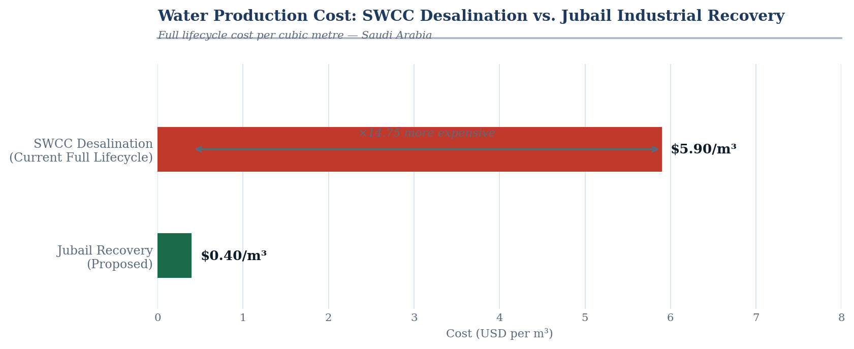
Fig. 4 Water production cost — SWCC desalination ($5.90/m³ full lifecycle) vs. Jubail industrial recovery ($0.40/m³); 93% unit cost reduction; saving potential $1.5–2.0B/yr at full scale
Cost Metric | Conventional Desalination (RO) | Waste-to-Water Recovery (MED on waste heat)
Water production cost (operational) | $0.40–$0.50/m³ (OPEX basis) | $0.15–$0.25/m³ (OPEX basis; heat is a by-product)
Full lifecycle cost (SWCC basis, 2020) | $5.90/m³ | Estimated $0.90–$1.40/m³ (capex amortised)
Energy consumption | 3–10 kWh/m³ (RO to MSF range) | <1 kWh/m³ (heat already generated)
Carbon footprint | High (fossil fuel dependent) | Near-zero incremental carbon
Brine management | Generates brine; additional cost | Reduces brine; environmental benefit
Payback period | Not applicable (primary infrastructure) | 17–24 years (Phase 1); 8–11 years at national scale

Phase 1 Pilot Financial Projections
Item | Estimate | Basis
Capital Investment (Phase 1) | $180–240 million | MED units, heat exchangers, condensation systems, civil works, instrumentation
Annual Operating Cost | $6–9 million/year | Labour, maintenance, chemicals, electricity for pumping and monitoring
Annual Water Produced | 18.25 million m³/year | 50,000 m³/day × 365 days
Avoided Desalination Cost (operational) | $7.3–9.1 million/year | At $0.40–0.50/m³ avoided desalination OPEX
Brine Disposal Savings | $1.5–2.5 million/year | Reduced brine discharge management and environmental compliance costs
Simple Payback Period | 17–24 years (Phase 1 alone) | Improves significantly at scale and with carbon credit valuation
Payback with carbon credit value ($30/tonne CO₂) | 12–16 years | Based on ~150,000 tonnes CO₂/year avoided vs. equivalent MSF production
ROI at Full National Scale (5 hubs) | 8–11 years | Economy of scale + shared infrastructure reduces unit capex 30–40%

GOVERNMENT INVESTMENT CONTEXT
MEWA has committed over $80 billion to water infrastructure under Vision 2030, with 104 billion SAR ($28 billion) already contracted through private partnerships. A $200–240 million pilot represents less than 0.3% of total committed water investment and could establish the template for a complementary water recovery infrastructure class that generates exponentially greater returns at national scale.

7B. INDUSTRIAL PARTNERSHIP MODEL
Industrial waste recovery infrastructure cannot be financed and deployed through government procurement alone. The capital intensity, the need for long-term heat and brine offtake agreements with private operators, and the multi-stakeholder governance requirements make this a natural candidate for a structured Public-Private Partnership model. The following framework is proposed for Phase 1 and national scale deployment.
PPP Structure: Build-Operate-Transfer
The recommended structure is a Build-Operate-Transfer arrangement in which a private consortium (led by an established water technology firm such as Veolia or IDE Technologies, in joint venture with SABIC or Saudi Aramco utilities divisions) finances, constructs and operates the recovery hub for a 20-year concession period. MEWA provides the regulatory framework and off-take guarantee. SWPC structures the project finance and manages the PPP tender process. At the end of the concession, assets transfer to the Saudi government at a pre-agreed residual valuation.
Industrial Partner Incentive Framework
Industrial operators at Jubail (Saudi Aramco, SABIC, SWCC) generate the waste heat and brine streams that the system depends on. Their cooperation is not voluntary goodwill; it requires structured commercial incentives. Three mechanisms are proposed. First, a mandatory industrial symbiosis framework under the National Waste Management Law (2024) requiring facilities above a defined energy output threshold to register waste heat streams with a central registry, creating the data infrastructure for future recovery agreements. Second, a commercial offtake agreement in which the recovery operator pays a nominal fee per gigajoule of waste heat accessed, creating a revenue stream for industrial partners from heat that is currently dissipated at no return. Third, brine disposal cost offset credits under which SWCC reduces per-cubic-metre brine disposal charges for facilities that route brine to secondary recovery, incentivising cooperation through cost reduction rather than regulation alone.
Government Risk Mitigation Instruments
To attract private capital at scale, the government needs to absorb the risks that private investors cannot price: regulatory uncertainty, off-take demand risk, and first-of-kind technology risk in the Saudi context. Three instruments are proposed. A minimum water off-take guarantee from MEWA covering 70 percent of rated capacity for the first ten years of operation, providing the revenue floor that project finance lenders require. A first-loss tranche of SAR 500 million from the Public Investment Fund (PIF) absorbing the first tier of capital loss in a downside scenario, reducing the blended cost of capital for the private consortium by an estimated 150 to 200 basis points. A carbon credit monetisation framework under the Saudi Green Initiative allowing the recovery operator to register and sell avoided emissions against a domestic carbon price mechanism, improving project economics without direct government subsidy.
Capital Structure: Phase 1 Target
Target capital structure for Phase 1 ($180 to $240 million total): Private equity and debt from the technology consortium (60 to 65 percent, approximately $110 to $155 million); PIF first-loss tranche and concessional loan (20 to 25 percent, approximately $36 to $60 million); MEWA co-investment and land contribution in-kind (10 to 15 percent, approximately $18 to $36 million). This structure limits direct government cash outlay to $54 to $96 million while mobilising three to four times that amount in private capital, consistent with Saudi Arabia’s broader Vision 2030 PPP targets for the water sector.
8. IMPLEMENTATION ROADMAP

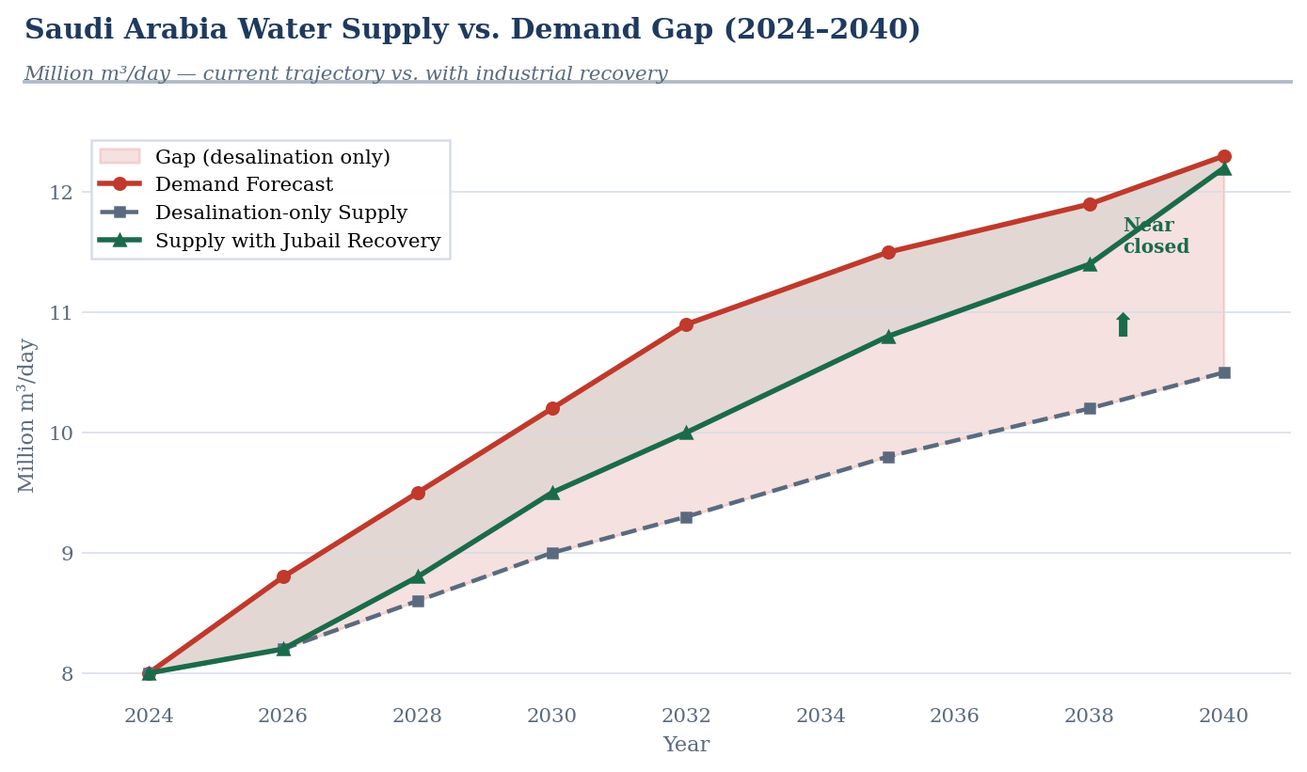
Fig. 5 Saudi Arabia water supply vs. 2040 demand — current supply (8.0M m³/day), 12.3M m³/day forecast by 2040, and supply trajectory with Jubail industrial recovery programme contribution
Phase | Timeline | Scope | Key Milestones
Phase 0: Feasibility & Design | Months 1–6 | Detailed engineering study, site surveys, MEWA/SWCC data access, technology partner shortlisting | Feasibility report; technology selection; MEWA approval of Phase 1 scope
Phase 1: Jubail Pilot | Months 7–30 | Brine secondary MED unit (40,000 m³/day) + flue gas condensation from 3 stacks (8,000 m³/day) + monitoring infrastructure | First water delivery at month 24; 18-month operational data collection
Phase 2: Evaluation & Optimisation | Months 31–42 | Performance audit, cost per m³ validation, quality compliance, community and regulator reporting | Go/No-Go decision for national scale; produced water scope defined
Phase 3: National Replication | Months 43–72 | Replication at Yanbu, Ras Al-Khair, Dammam hubs; produced water integration; NEOM integration | 300,000+ m³/day national recovery capacity; template export to GCC and global markets

9. RISK REGISTER

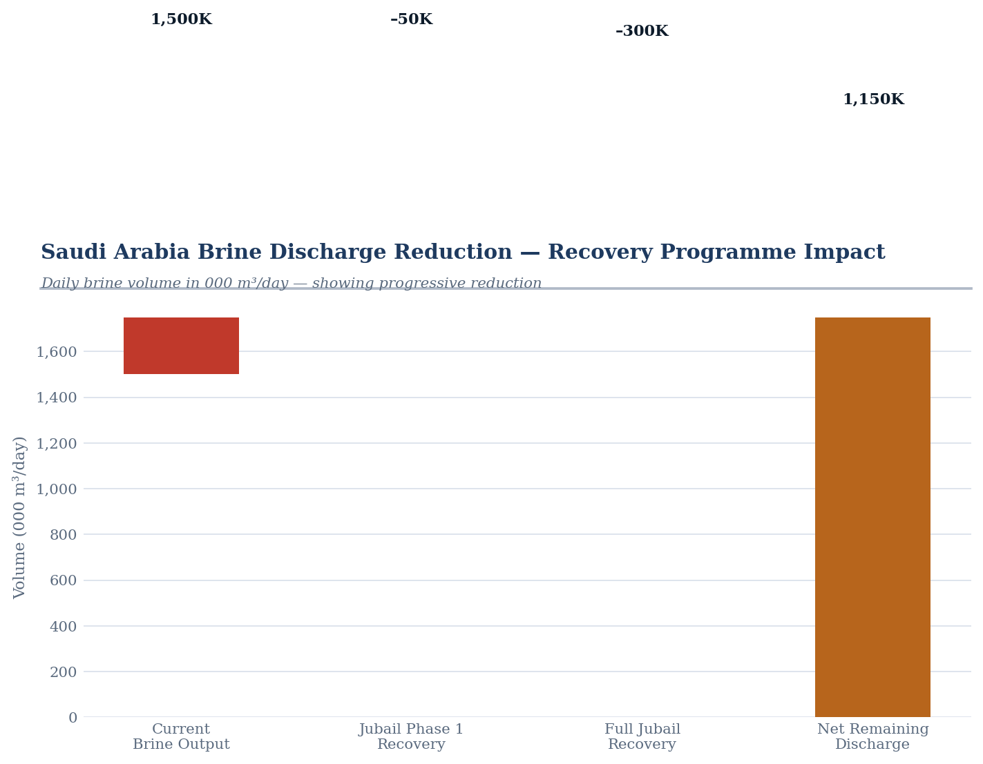
Fig. 6 KSA brine discharge reduction — current daily Gulf discharge (~1.0–1.5M m³/day) vs. Phase 1 recovery (50K m³/day) and full-scale programme recovery (350K m³/day)
Risk | Likelihood | Impact | Mitigation
Waste heat supply variability: industrial output fluctuates | Medium | Medium | Design system for 70% capacity operation; thermal buffer storage; multiple heat source inputs
Water quality below specification from brine recovery | Low-Medium | High | RO polishing stage included as fail-safe; continuous inline monitoring with automatic diversion
Industrial partner cooperation: access to waste streams | Medium | High | Formalise as MEWA-mandated industrial symbiosis under National Waste Management Law (2024); structure as commercial offtake agreements
Capital cost overrun | Medium | Medium | Modular procurement; phase MED units; fixed-price EPC contracts with established vendors (Veolia, IDE)
Geopolitical supply chain risk: imported MED components | Low | Medium | Prioritise SABIC and local fabrication where possible; dual-source critical components
Regulatory approval delays | Low | Medium | MEWA sponsorship eliminates primary approval risk; WERA coordinates electricity regulatory interface

10. GOVERNANCE & INSTITUTIONAL FRAMEWORK

Stakeholder | Role | Engagement Required
MEWA: Ministry of Environment, Water & Agriculture | Primary sponsor; regulatory approvals; data access | Co-sponsorship agreement; data sharing MOU; pilot funding allocation
SWCC: Saline Water Conversion Corporation | Brine discharge offtake partner; operational data | MOU for brine access; technical coordination on Jubail 3A interface
SWPC: Saudi Water Partnership Company | PPP procurement structuring for private investment | Involve from Phase 0 to structure project finance
Saudi Aramco | Waste heat and produced water access (Phase 2) | Letter of Intent; technical working group from Phase 1
SABIC | Industrial heat and flue gas access; potential local manufacturing partner | Commercial negotiation; industrial symbiosis framework
Royal Commission for Jubail & Yanbu (RCJY) | Site access, infrastructure corridors, utility interfaces | Coordinate utility routing; land access agreements
Global Water Organization (Riyadh) | Endorsement; international profile; export template | Advisory engagement; showcase for GWO's mandate
Technology Partners (Veolia, IDE, GE Water) | Engineering, procurement, construction; O&M | Competitive tender process; PPP structure

11. GLOBAL REPLICATION POTENTIAL

The system architecture is intentionally modular and parameter-driven, designed to be reconfigured for other industrial-water-scarce geographies. The core logic: industrial waste heat drives thermal water recovery from brine and process streams, is transferable across the GCC and globally.

Country / Region | Industrial Profile | Water Stress | Primary Adaptation
UAE (Abu Dhabi / Ruwais) | ADNOC refineries; desalination at Taweelah | Critical | Similar brine MED model; already strong PPP appetite
Kuwait | KPC refinery cluster; 90%+ reliance on desalination | Critical | Flue gas condensation focus; smaller industrial footprint
Oman (Sohar) | Oman Oil refineries; Port of Sohar industrial zone | High | Adjust for lower heat intensity; add solar pre-heat
India (Gujarat industrial coast) | ONGC produced water; coastal petrochemicals | High | Produced water focus; government financing mechanism differs
North Africa (Algeria / Libya) | State oil refineries; Mediterranean desalination | High-Medium | Adapt for Mediterranean brine salinity; EU co-financing possible

Saudi Arabia's establishment of the Global Water Organization positions the Kingdom to not merely implement this system domestically, but to export the validated model and associated technical standards, creating significant soft-power and economic value alongside water security.

12. REQUESTED ACTIONS

We respectfully request the Ministry's consideration of the following specific actions to initiate the programme:

- Action 1: Approve and formally sponsor the Phase 0 Feasibility Study, enabling access to MEWA and SWCC operational data required for detailed engineering design.
- Action 2: Allocate SAR 15–20 million (approx. $4–5.3 million) for Phase 0 feasibility, site surveys, and technology benchmarking, to be offset against Phase 1 CAPEX upon approval.
- Action 3: Facilitate introductions to SWCC, Saudi Aramco, SABIC, and RCJY for industrial waste stream access discussions and Letter of Intent execution.
- Action 4: Engage SWPC to begin structuring the PPP financing framework for Phase 1 capital investment, targeting private sector funding for 60–70% of CAPEX.
- Action 5: Consider endorsement by the Global Water Organization to position this programme as an international showcase of Saudi circular water infrastructure.

SUMMARY OF THE OPPORTUNITY
Saudi Arabia already has the infrastructure, the industrial density, and the policy mandate. The waste heat is being generated daily. The brine is being discharged daily. The 4.5 million m³/day water gap is widening annually. This proposal does not ask for new energy, new desalination plants, or new demand constraints. It asks for permission to recover what is already being lost.

DATA SOURCES & REFERENCES

The following primary sources inform the data presented in this proposal:

- General Authority for Statistics, Saudi Arabia: Volume of water produced by desalination plants, 2010–2022 (Statista, Jan 2024)
- MEWA / US-Saudi Business Council: Water in Saudi Arabia: Desalination, Wastewater and Privatization (Feb 2022)
- Arab News: Saudi Arabia leads global desalinated water production surge (Jun 2024)
- ScienceDirect: Towards green desalination: Hybrid renewable energy in Saudi Arabian RO plants (Sep 2024)
- MEWA Official Statement: Saudi Arabia Targets 50% Cut in Water Production Costs by 2035 (MEWA News, 2024)
- Ken Research: Saudi Arabia Waste Heat Recovery System Market Report (Nov 2025)
- US–Saudi Business Council: Saudi Arabia Water Sector Economic Brief (Feb 2022)
- Oliver Wyman: 8 Trends That Could Transform Global Water Accessibility (Dec 2025)
- Arab Center DC: The Costs and Benefits of Water Desalination in the Gulf (Apr 2023)
- Wikipedia / UN Water Data: Water Supply and Sanitation in Saudi Arabia (cited Mar 2026)

